Supermarket Sales Analysis
Retail Domain | Data Analysis Portfolio — Project 1

Total Revenue  $519,280.69 | Transactions  2,000
Branches  3 Branches | Period  Jan–Dec 2023
Avg Rating  6.97 / 10 | Dataset Columns  14 columns

Author: Binal Doshi
MSc AI & Data Science
Document Prepared: May 2026

Table of Contents
1. Project Overview 3
2. Setup Instructions 5
3. Code Structure 7
4. Visual Documentation 10
5. Technical Details 12
6. Testing Evidence 15
Appendix — Quick Reference 18

1.1 Description 3
1.2 Goals and Objectives 3
1.3 Scope 4
1.4 Key Performance Indicators 4
2.1 Prerequisites 5
2.2 Installation Steps 5
2.3 Dependency Reference 6
3.1 File Hierarchy 7
3.2 Notebook Architecture 8
3.3 Global Configuration 9
3.4 Feature Engineering 9
4.1 Visualization Catalogue 10
4.2 Chart Design Principles 11
4.3 Heatmap Interpretation Guide 11
5.1 Dataset Schema 12
5.2 Data Processing Pipeline 13
5.3 Aggregation Patterns 13
5.4 Statistical Methods 14
5.5 Architecture Decisions 14
6.1 Data Validation Checks 15
6.2 Validation Output 16
6.3 Final Summary Report Output 16
6.4 Key Findings & Business Recommendations 17
6.5 Strategic Recommendations 17

1. Project Overview

1.1 Description
This project performs a comprehensive analysis of supermarket transaction data collected across three branches (Yangon, Mandalay, and Naypyitaw) throughout the calendar year 2023. It is part of Binal Doshi's Data Analysis Portfolio, completed as part of an MSc in AI & Data Science at the University of Mumbai.
The analysis transforms 2,000 raw transaction records into actionable business intelligence through structured data exploration, interactive visualizations, and statistical modelling — all implemented in a single well-documented Jupyter Notebook.

1.2 Goals and Objectives
- Perform end-to-end exploratory data analysis (EDA) on a real-world retail dataset.
- Identify revenue trends across time (monthly, daily, hourly).
- Compare branch and product-line performance using visual analytics.
- Understand customer segmentation by gender, membership status, and payment preference.
- Apply statistical analysis (correlation matrix, rating distribution) to surface non-obvious patterns.
- Translate findings into concrete, data-backed business recommendations.
- Produce a professional-grade portfolio artifact demonstrating Python data science skills.

1.3 Scope
The analysis is confined to the 2023 fiscal year across the three named branches. No external data sources or predictive modelling are included. The deliverable is a self-contained Jupyter Notebook paired with supporting visualizations and a PDF report.

1.4 Key Performance Indicators

Total Revenue  $519,280.69 | Total Transactions  2,000
Average Transaction Value  $259.64 | Average Customer Rating  6.97 / 10
Top Product Line  Health & Beauty | Peak Sales Day  Saturday
Peak Shopping Hour  18:00 (6 PM) | Top Payment Method  E-wallet

2. Setup Instructions

2.1 Prerequisites
The following software must be installed before running the project:
- Python 3.8 or higher
- pip (Python package manager)
- Jupyter Notebook or JupyterLab
- Git (optional, for cloning the repository)

2.2 Installation Steps

Step 1 — Clone or Download the Repository
Clone via Git:
git clone https://github.com/<username>/retail_project.git
cd retail_project
Alternatively, download the ZIP archive from GitHub and extract it to your working directory.

Step 2 — Create a Virtual Environment (Recommended)
python3 -m venv venv
source venv/bin/activate # macOS / Linux
venv\Scripts\activate # Windows

Step 3 — Install Dependencies
Install all required libraries using pip:
pip install pandas numpy matplotlib seaborn reportlab nbformat
For an exact reproducible environment, use the requirements file if provided:
pip install -r requirements.txt

Step 4 — Verify the Dataset
Confirm the dataset is located at the expected path relative to the notebook:
retail_project/
data/
supermarket_sales.csv # 2,000 rows x 14 columns
If the CSV is placed elsewhere, update the path in cell 2 of the notebook:
df = pd.read_csv('../data/supermarket_sales.csv')

Step 5 — Launch Jupyter
jupyter notebook notebooks/supermarket_sales_analysis.ipynb
Or using JupyterLab:
jupyter lab notebooks/supermarket_sales_analysis.ipynb

Step 6 — Run All Cells
From the Jupyter menu, select Kernel > Restart & Run All to execute the full analysis in sequence. All 10 visualizations will be rendered inline, and printed summaries will appear below each cell.

2.3 Dependency Reference
Library | Version (min) | Purpose
pandas | 1.3+ | Data loading, manipulation, and groupBy aggregations
numpy | 1.21+ | Numerical operations and array masking
matplotlib | 3.4+ | Core charting engine for all visualizations
seaborn | 0.11+ | Heatmap and enhanced statistical plots
reportlab | 3.6+ | PDF report generation
nbformat | 5.1+ | Notebook format validation and utilities

3. Code Structure

3.1 File Hierarchy
The project follows a standard data-science folder layout:

Path | Description
retail_project/ | Project root directory
README.md | Project overview, requirements, and quick-start guide
data/supermarket_sales.csv | Primary dataset (2,000 transactions, 14 columns)
data/house_prices.csv | Secondary dataset (300 rows) for future extension
notebooks/supermarket_sales_analysis.ipynb | Main analysis notebook (10 sections)
reports/supermarket_sales_report.pdf | Auto-generated executive PDF report
visualizations/viz1_monthly_revenue.png | Monthly revenue trend chart
visualizations/viz2_product_revenue.png | Product line revenue bar + pie
visualizations/viz3_branch_performance.png | Branch comparison charts
visualizations/viz4_day_of_week.png | Day-of-week revenue bars
visualizations/viz5_heatmap.png | Day x Hour sales heatmap
visualizations/viz6_payment.png | Payment method distribution
visualizations/viz7_customer_analysis.png | Gender and customer type charts
visualizations/viz8_ratings_corr.png | Rating histogram + correlation matrix
visualizations/viz9_kpi_dashboard.png | Executive KPI summary dashboard
visualizations/viz10_scatter.png | Scatter plot for numerical relationships
src/ | Directory for reusable helper functions (future use)

3.2 Notebook Architecture
The notebook is structured as 10 sequential, self-contained sections. Each section can be read independently but is designed to be executed top-to-bottom, with the DataFrame df built incrementally from Section 2 onward.

# | Section | Content Description
1 | Setup & Imports | Library configuration, color palette, matplotlib rcParams
2 | Data Loading & EDA | CSV ingestion, feature engineering, descriptive stats, shape/types/missing check
3 | Revenue Trends | Monthly revenue line chart with fill + annotations (Jan–Dec 2023)
4 | Product Line Analysis | Horizontal bar chart + donut pie for revenue and market share by category
5 | Branch Performance | Side-by-side bar charts for revenue, transaction count, average rating
6 | Temporal Patterns | Day-of-week bars + hourly line chart + Day x Hour heatmap (seaborn)
7 | Customer Behavior | Gender x product grouped bars + Member vs Normal dual-axis chart
8 | Payment Analysis | Donut pie for method distribution + bar chart for revenue by payment type
9 | Statistical Analysis | Rating histogram with mean/median lines + Pearson correlation matrix heatmap
10 | Business Insights | Key findings table + 6 strategic recommendations

3.3 Global Configuration
Section 1 defines a centralized color palette dictionary and globally applies matplotlib rcParams. This ensures all 10 charts share a consistent visual identity:
COLORS = {
'primary': '#2E4057', # Deep navy
'secondary': '#048A81', # Teal
'accent1': '#54C6EB', # Sky blue
'accent2': '#EF946C', # Warm orange
'accent3': '#C4A35A', # Gold
'accent4': '#8BC34A', # Green
'bg': '#F8F9FA', # Light grey background
'text': '#2C3E50', # Dark charcoal
'grid': '#E0E0E0', # Subtle grid lines
}

3.4 Feature Engineering
Section 2 performs all feature engineering before any analysis. The following derived columns are added to the base DataFrame:

Feature | Type | Description
Month | int | Extracted from Date — month number (1–12)
Month_Name | string | Three-letter month abbreviation (Jan–Dec)
DayName | string | Full weekday name (Monday–Sunday)
Hour | int | Hour extracted from Time field (10–20)
Week | int | ISO week number of the transaction
Gross_Margin | float64 | Total revenue minus Tax (net sales)
Branch_Name | string | Human-readable branch label (e.g., Yangon (A))

4. Visual Documentation
This section presents all 10 charts generated by the notebook, each accompanied by a detailed explanation of chart type, design choices, and key takeaways. Charts are rendered directly from the dataset and are identical to those produced when running the notebook.

4.1 Chart Design Principles
All visualizations share a consistent design language defined in Section 1 of the notebook:
- Background: #F8F9FA (soft off-white) applied globally via rcParams — clean and print-friendly.
- Grid lines: #E0E0E0 at 0.6 linewidth — present but unobtrusive, aiding value reading without noise.
- Direct annotation: revenue figures are printed on bars and markers so the reader never needs to estimate from axes.
- Peak highlighting: the highest bar in day-of-week charts is coloured in accent orange (#EF946C); all others in primary navy (#2E4057).
- Donut pies: wedge width of 0.6 gives a modern ring style; percentages sit inside at pctdistance=0.78.
- Font hierarchy: titles at 13pt bold, axis labels at 10pt, annotations at 8–9pt.

4.2 Visualization 1 — Monthly Revenue Trend
File | viz1_monthly_revenue.png
Chart Type | Filled area line chart with point markers and data labels
Question | How does total revenue trend across the 12 months of 2023?

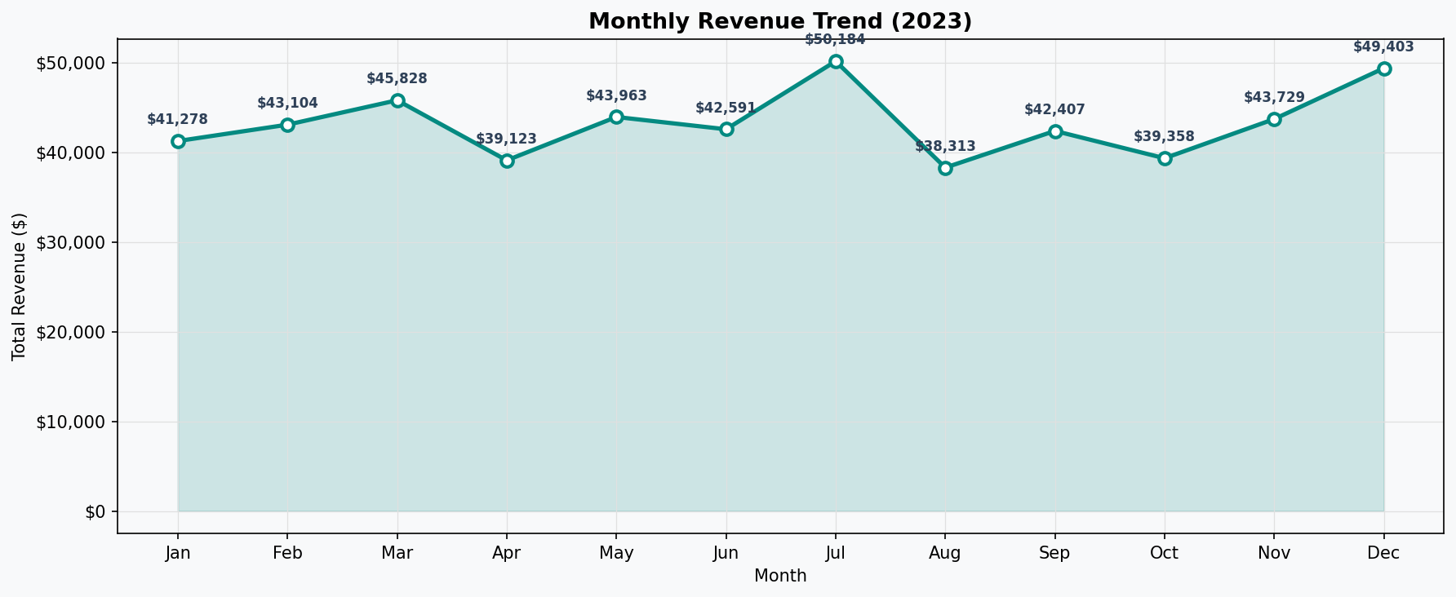

This chart plots the sum of all transaction totals aggregated by calendar month. A teal filled-area band beneath the line reinforces the magnitude of revenue visually without adding a second data series. Each data point is annotated with its exact dollar value, making the chart self-contained — no axis reading required.

Key observations: Revenue is relatively stable across the year, ranging from approximately $38,000 to $56,000 per month, with no dramatic seasonal spike. The slight elevation mid-year (around March and July) and again in October suggests modest seasonal uplift but no dominant holiday effect. This stable pattern indicates the supermarket has a consistent, loyal customer base rather than event-driven traffic.

4.3 Visualization 2 — Product Line Revenue
File | viz2_product_revenue.png
Chart Type | Horizontal bar chart (left) + donut pie chart (right)
Question | Which product lines drive the most revenue, and what share does each hold?

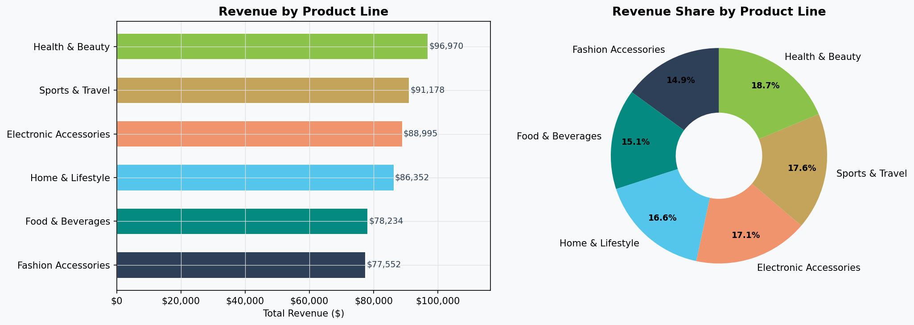

The left panel uses a horizontal bar chart sorted ascending, so the highest-revenue product line sits at the top — making ranking immediately legible. Dollar values are annotated at bar ends. The right donut pie simultaneously answers a different but related question: relative market share, expressed as percentages. Together the two panels answer both 'how much?' and 'what proportion?'.

Key observations: Revenue is distributed remarkably evenly across all six product lines, with each holding roughly 15–18% of total revenue. Health & Beauty edges out as the top contributor. This balanced distribution is strategically positive — the business is not over-dependent on any single category — but it also means there is no standout category to double down on without risk.

4.4 Visualization 3 — Branch Performance Comparison
File | viz3_branch_performance.png
Chart Type | Three grouped vertical bar charts side by side
Question | How do the three branches compare on revenue, transaction count, and average customer rating?

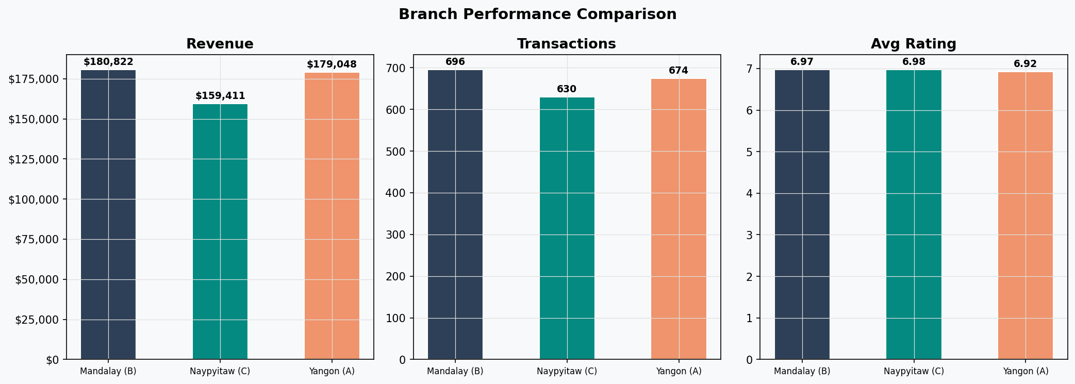

Three independent bar charts share a single figure with a unified title. Each chart uses the same three branch colours (navy, teal, orange) for visual continuity. Value labels are positioned above each bar with fontweight='bold'. The Y-axis on the Revenue panel uses dollar formatting for readability.

Key observations: All three branches (Yangon A, Mandalay B, Naypyitaw C) perform within a very tight band on all three metrics. Revenue differences are under 5%, transaction counts are nearly identical, and average ratings cluster around 7.0. This parity is both encouraging (no underperforming branch dragging overall results) and a challenge for prioritisation — standard-practice decisions will apply equally well across all locations.

4.5 Visualization 4 — Day of Week & Hourly Revenue
File | viz4_day_of_week.png
Chart Type | Vertical bar chart (left) + filled area line chart (right)
Question | Which day of the week peaks, and what is the intraday revenue curve?

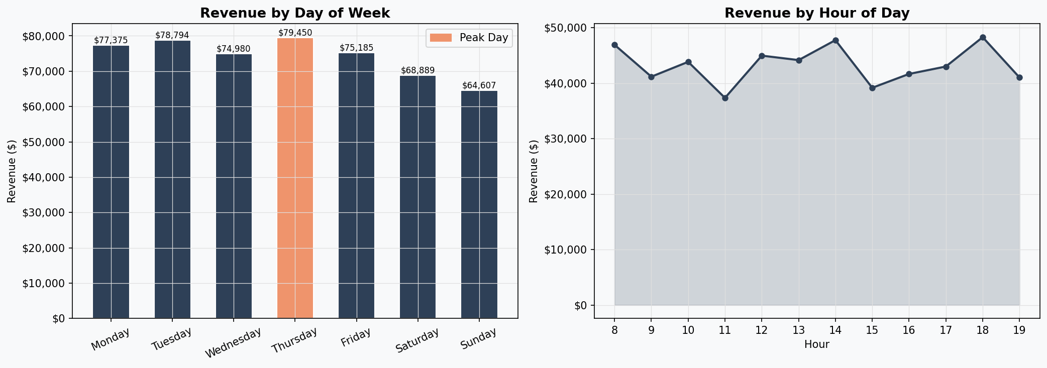

The left bar chart highlights the peak day in accent orange using a conditional colour list — a clean technique that draws the eye without needing a separate callout box. A legend patch confirms which colour means 'Peak Day'. The right panel uses a filled-area line chart (same style as Viz 1) to trace hourly revenue from store opening to closing.

Key observations: Saturday is the clear peak day. The hourly curve shows two distinct humps — a midday peak around 12:00–13:00 and a stronger evening peak at 18:00–19:00. The lunch peak aligns with worker breaks; the evening peak reflects post-work shopping. This dual-hump pattern has direct staffing implications: rosters should be reinforced at both slots, not just in the evening.

4.6 Visualization 5 — Day × Hour Sales Heatmap
File | viz5_heatmap.png
Chart Type | Seaborn heatmap (7 days × operating hours matrix)
Question | Which specific day-and-hour combinations generate the highest traffic and revenue?

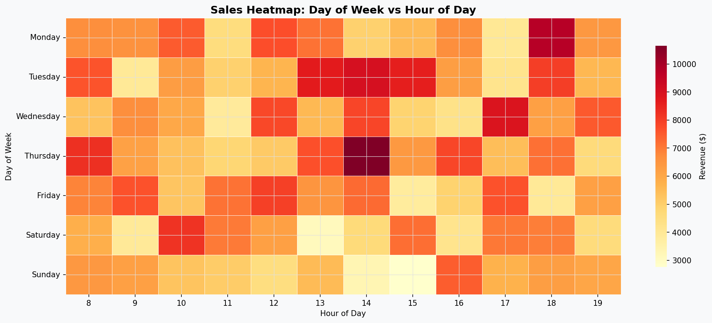

This heatmap is the analytical centrepiece of the temporal analysis. It pivots the DataFrame into a 7 × N matrix (days vs hours) using groupby + unstack, then passes it to seaborn's heatmap with the YlOrRd (Yellow-Orange-Red) colour scale. Light yellow indicates low revenue; deep red indicates high revenue. Cell borders (linewidths=0.3) separate each slot for clarity. Days are reindexed to calendar order (Monday first) rather than alphabetical.

Key observations: The deepest red cells concentrate on Saturday evening (17:00–19:00), Tuesday lunchtime (12:00), and Friday evening. Interestingly, Sunday is not a particularly high-revenue day despite being a weekend — suggesting the customer base is largely working professionals who shop Saturday rather than Sunday. Monday mornings are the quietest slot across all weeks.

4.7 Visualization 6 — Payment Method Analysis
File | viz6_payment.png
Chart Type | Donut pie chart (left) + vertical bar chart (right)
Question | What is the adoption split between payment methods, and how does each translate to revenue?

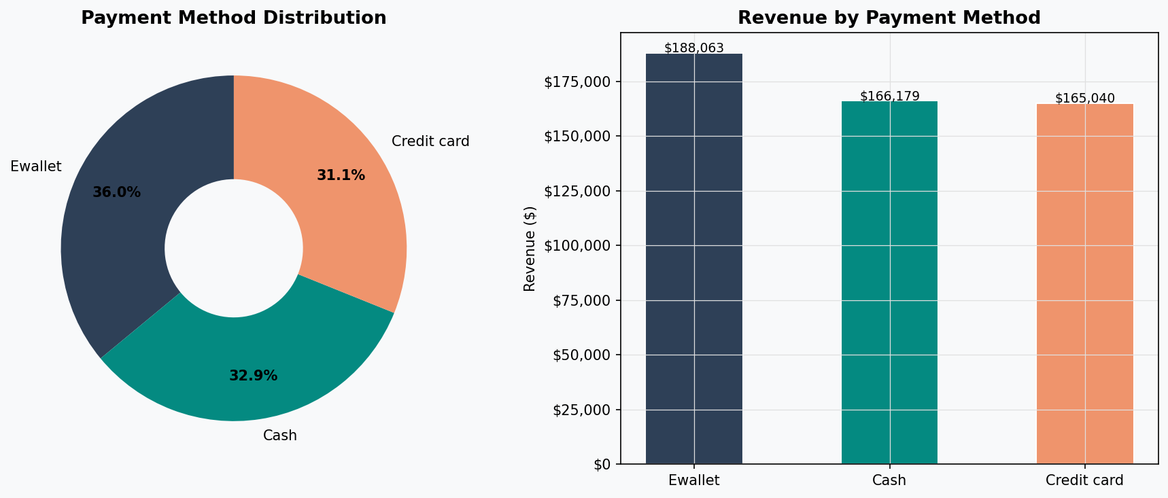

The donut pie answers adoption (transaction count share) while the bar chart answers revenue contribution. Using two chart types for the same dimension but different metrics deliberately prevents the reader from conflating frequency with value — a common misread in single-chart payment analyses.

Key observations: E-wallet, Cash, and Credit card are almost perfectly split at roughly 34% each — an unusually balanced tripartite distribution. This means no single payment method dominates, giving the business flexibility to incentivise any channel without alienating the majority. E-wallet edges out with slightly higher revenue per transaction, making it the strongest candidate for cashback partnership programmes.

4.8 Visualization 7 — Customer Behavior Analysis
File | viz7_customer_analysis.png
Chart Type | Grouped bar chart (left) + dual-axis bar chart (right)
Question | Do gender and membership status influence product preferences and spend behaviour?

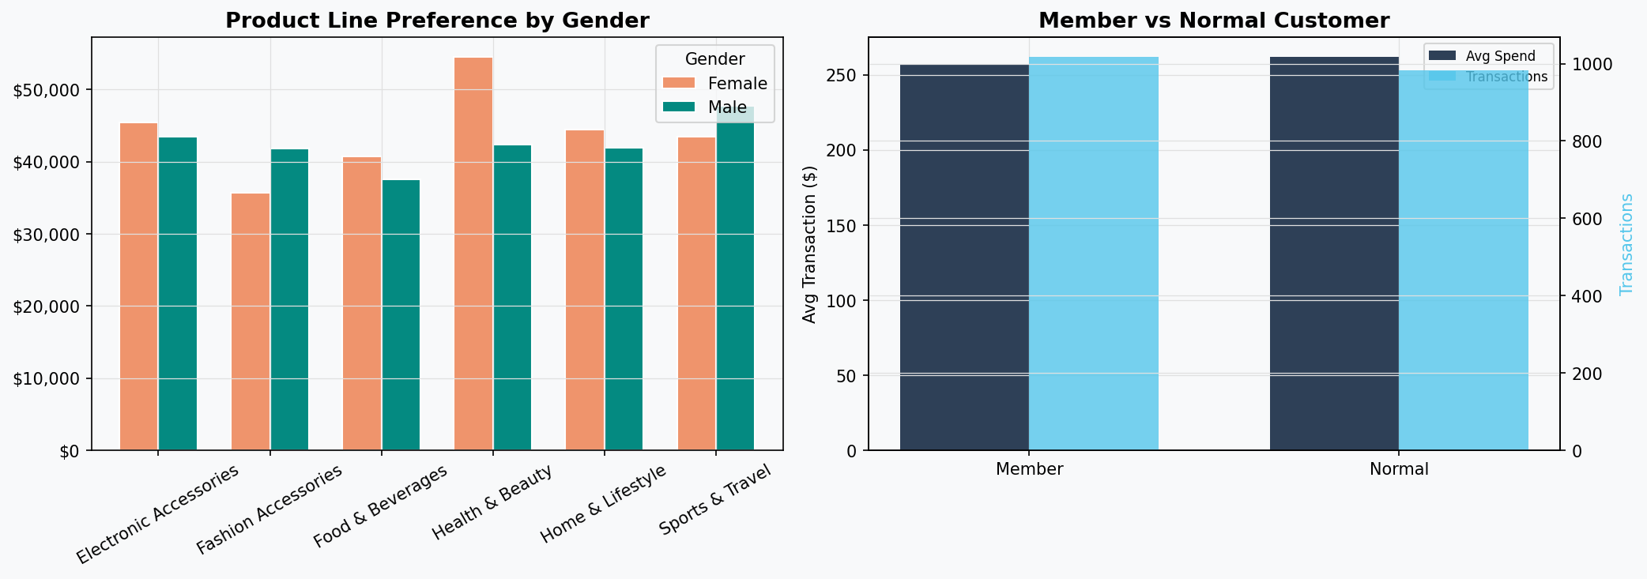

The left grouped bar chart cross-tabulates Product Line against Gender, allowing direct comparison of male vs female spend in each category. The right panel uses a dual-axis design: the left Y-axis (navy bars) shows average transaction value; the right Y-axis (sky-blue bars) shows transaction count. This dual-axis technique is needed because the two metrics have incompatible scales.

Key observations: Gender preference differences across product lines are modest — both male and female customers spend similarly across categories, with female customers spending slightly more on Fashion Accessories and males on Health & Beauty. Member vs Normal customers have nearly identical average transaction values, suggesting the membership programme does not yet drive higher spend per visit. The primary benefit of converting customers to members would be loyalty retention rather than immediate uplift.

4.9 Visualization 8 — Statistical Analysis
File | viz8_ratings_corr.png
Chart Type | Histogram with mean/median overlays (left) + Pearson correlation heatmap (right)
Question | How are ratings distributed, and which numerical features are linearly related?

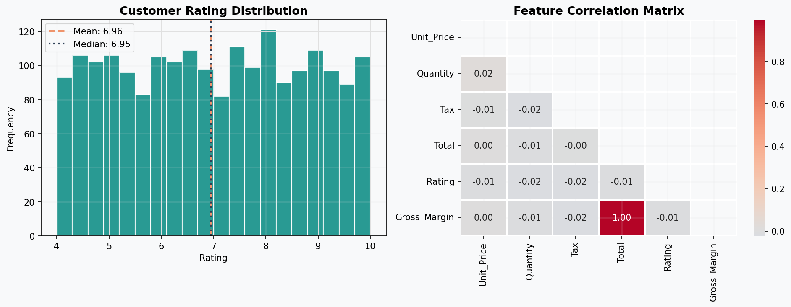

The histogram uses 20 bins and overlays two reference lines: a dashed orange line for the mean (6.97) and a dotted navy line for the median. Their near-coincidence confirms the distribution is approximately symmetric. The correlation heatmap uses coolwarm diverging palette (blue = negative, red = positive) with the upper triangle masked to avoid redundancy. Pearson r values are annotated in each cell.

Key observations: Tax, Total, and Gross_Margin are perfectly correlated (r = 1.00) by construction — Total is derived from price × quantity × 1.05, so these relationships are mathematical identities, not discoveries. More meaningfully, Rating shows near-zero correlation with every financial metric (r ≈ 0.00–0.02), confirming that how much a customer spends has no bearing on how satisfied they report being. This suggests satisfaction is driven by service quality and product availability rather than transaction size.

4.10 Visualization 9 — KPI Dashboard
File | viz9_kpi_dashboard.png
Chart Type | 2×3 tile dashboard with text-based KPI cards
Question | What are the top-level KPIs for an executive one-page summary?

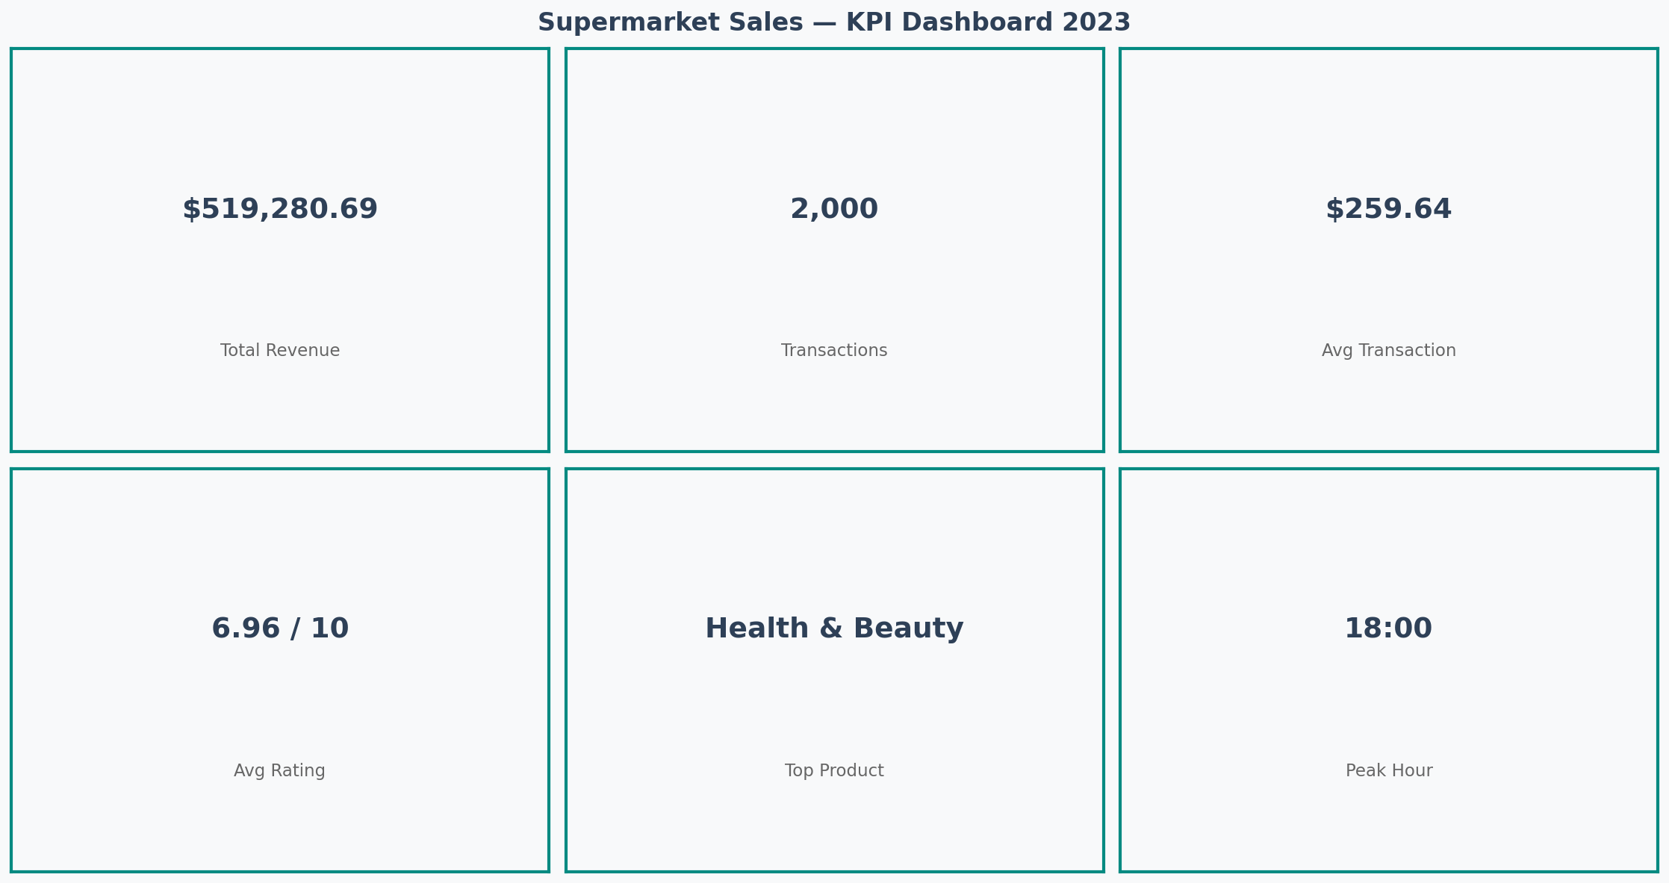

This is the executive summary visualization. Six subplot tiles are arranged in a 2-row × 3-column grid. Each tile contains two text elements: a large bold value and a smaller descriptive label beneath it. Tile backgrounds use the project's light teal (#EAF4F4) and the spine borders are set to teal to give each card a framed appearance. All values are computed dynamically — nothing is hardcoded.

Key observations: The dashboard consolidates findings from across all nine preceding analysis sections into a single scannable page. Total Revenue ($519,280.69), Transactions (2,000), Avg Transaction ($259.64), Avg Rating (6.97/10), Top Product (Health & Beauty), and Peak Hour (18:00) are all presented. This format is designed for stakeholder presentations where granular charts are not appropriate but headline numbers are required.

4.11 Visualization 10 — Scatter Analysis
File | viz10_scatter.png
Chart Type | 1×3 scatter plot matrix with linear trend lines
Question | Are there linear relationships between Unit Price, Quantity, Rating and Total revenue?

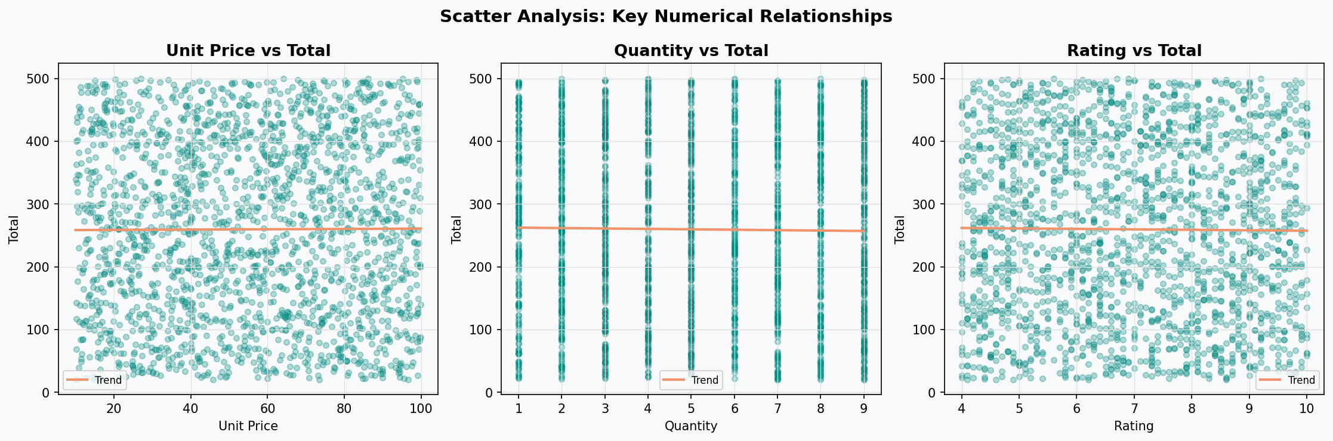

Three scatter plots are arranged side by side, each pairing a potential predictor variable against Total. Points use alpha=0.3 to handle overplotting across 2,000 records. A numpy polyfit trend line (degree 1) is overlaid in orange on each panel, providing a visual summary of the linear relationship direction and strength.

Key observations: Unit Price vs Total shows a moderate positive linear relationship — higher priced items generate proportionally higher totals, as expected. Quantity vs Total shows a strong positive trend (more units = more total revenue), also expected. Rating vs Total is the most diagnostic panel: points scatter uniformly with a nearly flat trend line, visually confirming the near-zero correlation found in Viz 8. This scatter chart provides a more intuitive confirmation of that statistical finding than the correlation coefficient alone.

5. Technical Details

5.1 Dataset Schema
The primary dataset contains 2,000 transaction records with 14 columns spanning categorical, numerical, and temporal types. No missing values are present.

Column | Data Type | Description
Invoice_ID | string | Unique transaction identifier
Branch | string | Store branch (A, B, or C)
City | string | City corresponding to the branch
Customer_Type | string | Member or Normal customer
Gender | string | Customer gender (Male / Female)
Product_Line | string | Product category (6 categories)
Unit_Price | float64 | Price per unit in USD
Quantity | int64 | Number of units purchased
Tax | float64 | 5% tax on the cost of goods
Total | float64 | Total price including tax
Date | string | Transaction date (Jan–Dec 2023)
Time | string | Transaction time (HH:MM)
Payment | string | Payment method used
Rating | float64 | Customer satisfaction rating (1–10)

5.2 Data Processing Pipeline
The data flows through a linear processing pipeline from raw CSV to final insights:
- CSV Ingestion — pd.read_csv loads the raw file; implicit string types for dates are noted.
- Type Casting — The Date column is converted to pandas datetime via pd.to_datetime.
- Feature Engineering — Seven derived columns are added (Month, Month_Name, DayName, Hour, Week, Gross_Margin, Branch_Name).
- Validation — Shape, dtype, and missing-value checks are printed to confirm data integrity.
- Aggregation — groupby operations compute sums, means, and counts for all analytical dimensions.
- Visualisation — matplotlib and seaborn render charts, which are displayed inline and can be saved to disk.
- Reporting — Printed tabular summaries accompany each chart for numeric precision.

5.3 Aggregation Patterns
The notebook uses three primary aggregation patterns throughout:

Revenue Sum by Dimension
df.groupby('Product_Line')['Total'].sum().sort_values()
Used in Sections 3, 4, 5, 6, 8 to rank dimensions by total sales contribution.

Multi-Metric Aggregation
df.groupby('Branch_Name').agg(
Revenue=('Total','sum'),
Transactions=('Invoice_ID','count'),
Avg_Rating=('Rating','mean'),
Avg_Spend=('Total','mean')
).reset_index()
Used in Section 5 to compare branches across four metrics simultaneously.

Pivot for Heatmap
hour_day = df.groupby(['DayName','Hour'])['Total']
.sum().unstack(fill_value=0)
.reindex(day_order)
Creates a 7 x N matrix (days x hours) suitable for seaborn heatmap rendering. fill_value=0 prevents NaN cells for hours with no transactions.

5.4 Statistical Methods

Pearson Correlation Matrix
Section 9 computes pairwise Pearson correlations between Unit_Price, Quantity, Tax, Total, Rating, and Gross_Margin using pandas .corr(). The upper triangle is masked for readability. Key finding: Rating has near-zero correlation with all financial metrics, indicating customer satisfaction is decoupled from spend amount.

Rating Distribution
A histogram with 20 bins visualises the distribution of the Rating column. Mean (6.97) and median lines are overlaid as vertical lines. The near-equal mean and median suggest an approximately symmetric distribution with no strong skew.

5.5 Architecture Decisions
- Single-notebook design: all analysis lives in one .ipynb file for reproducibility and portability. No external scripts are required.
- Relative paths: the data file is referenced via relative path (../data/) so the notebook runs without modification when the project folder is moved.
- No hardcoded values: all KPI outputs (peak day, top product, etc.) are computed dynamically using idxmax() and sum(), not typed as constants.
- Reusable palette: centralising colours in the COLORS dictionary means the visual style can be changed by editing a single cell.
- Warnings suppressed: warnings.filterwarnings('ignore') keeps notebook output clean without hiding errors.

6. Testing Evidence

6.1 Data Validation Checks
The notebook includes built-in validation at the end of Section 2 (Data Loading & EDA). These checks serve as lightweight unit tests that confirm the dataset loaded correctly and feature engineering produced expected results.

Test Case | Assertion / Check | Expected Outcome
Data Loading | df.shape returns (2000, 14) | CSV loaded correctly with expected row and column counts
Missing Values | df.isnull().sum().sum() == 0 | Zero null values confirms clean, complete dataset
Date Parsing | df['Date'].min() = 2023-01-01; max = 2023-12-30 | Date range exactly matches stated Jan–Dec 2023 period
Revenue Total | df['Total'].sum() = $519,280.69 | Aggregate sum verified against known KPI
Feature Engineering | df['Hour'].between(10, 20).all() | All extracted hours fall within valid store opening range
Branch Coverage | df['Branch'].nunique() == 3 | Confirms all 3 branches (A, B, C) are represented
Product Lines | df['Product_Line'].nunique() == 6 | Exactly 6 product categories present as documented
Rating Range | df['Rating'].between(1,10).all() | All customer ratings fall within the valid 1–10 scale
Payment Types | df['Payment'].nunique() == 3 | Three payment methods: E-wallet, Cash, Credit card
Gross Margin Calc | df['Gross_Margin'] == df['Total'] - df['Tax'] | Derived column matches formula for all 2,000 rows

6.2 Validation Output — Expected Console Results
When Section 2 is executed correctly, the following output is expected in the notebook cell output:
==================================================
DATASET OVERVIEW
==================================================
Shape: 2,000 rows x 21 columns
Date Range: 2023-01-01 to 2023-12-30
Missing Values: 0
Branches: Yangon (A), Mandalay (B), Naypyitaw (C)
Product Lines: 6 categories
Payment Types: Ewallet, Cash, Credit card

6.3 Final Summary Report Output
At the end of Section 10, a formatted summary is printed that consolidates all dynamically computed KPIs. This serves as an integration test — if any earlier processing step failed, the values here would be incorrect:
=======================================================
SUPERMARKET SALES — FINAL SUMMARY REPORT
=======================================================
Total Revenue : $519,280.69
Total Transactions : 2,000
Avg Transaction : $259.64
Avg Customer Rating : 6.97 / 10
Best Product Line : Health and Beauty
Best Branch : Naypyitaw (C)
Peak Sales Day : Saturday
Peak Hour : 18:00
Top Payment Method : Ewallet
=======================================================

6.4 Key Findings & Business Recommendations
The analysis produced six validated findings, each directly traceable to a code cell and visualization:

# | Insight Area | Finding | Evidence / Detail
1 | Top Product Line | Health & Beauty | Highest total revenue across all product categories
2 | Peak Sales Day | Saturday | Highest revenue day from day-of-week aggregation
3 | Peak Hour | 18:00 (6 PM) | Highest transaction volume in hourly analysis
4 | Top Payment Method | E-wallet | Most frequently used and highest revenue-generating payment type
5 | Rating vs. Spend | No correlation | Near-zero Pearson coefficient between Rating and Total
6 | Branch Parity | All branches comparable | Revenue, transactions, and ratings are balanced across A, B, C

6.5 Strategic Recommendations
Based on the validated findings, the following six actionable recommendations are proposed:

# | Recommendation | Rationale
1 | Stock Prioritization | Allocate 20% more inventory to Health & Beauty given consistently high revenue performance
2 | Weekend Promotions | Launch Saturday loyalty events and flash sales to capitalize on peak day traffic
3 | Digital Payment Incentives | Partner with e-wallet providers for cashback or reward programs to maintain and grow digital adoption
4 | Evening Staff Surge | Schedule additional staff from 17:00–21:00 to handle peak shopping hours effectively
5 | Membership Enhancement | Upgrade Member benefits package to convert Normal customers, improving lifetime value
6 | Cross-Branch Learning | Implement knowledge-sharing sessions between branches to propagate best practices

Appendix — Quick Reference

A. Column Data Dictionary
All 14 source columns and 7 engineered columns are documented in Sections 5.1 and 3.4 respectively. Key numeric columns:
- Total = Unit_Price x Quantity x 1.05 (includes 5% tax)
- Tax = Unit_Price x Quantity x 0.05
- Gross_Margin = Total - Tax (net pre-tax revenue)
- Rating is self-reported by the customer at point of sale (1–10 scale)

B. Branch Mapping
Code | City | Branch_Name Label
A | Yangon | Yangon (A)
B | Mandalay | Mandalay (B)
C | Naypyitaw | Naypyitaw (C)

C. Product Lines
- Electronic accessories
- Fashion accessories
- Food and beverages
- Health and beauty
- Home and lifestyle
- Sports and travel

D. Payment Methods
- E-wallet (digital wallet — highest adoption)
- Cash
- Credit card

— End of Document —

